Test Case 1: To Add Product to cart

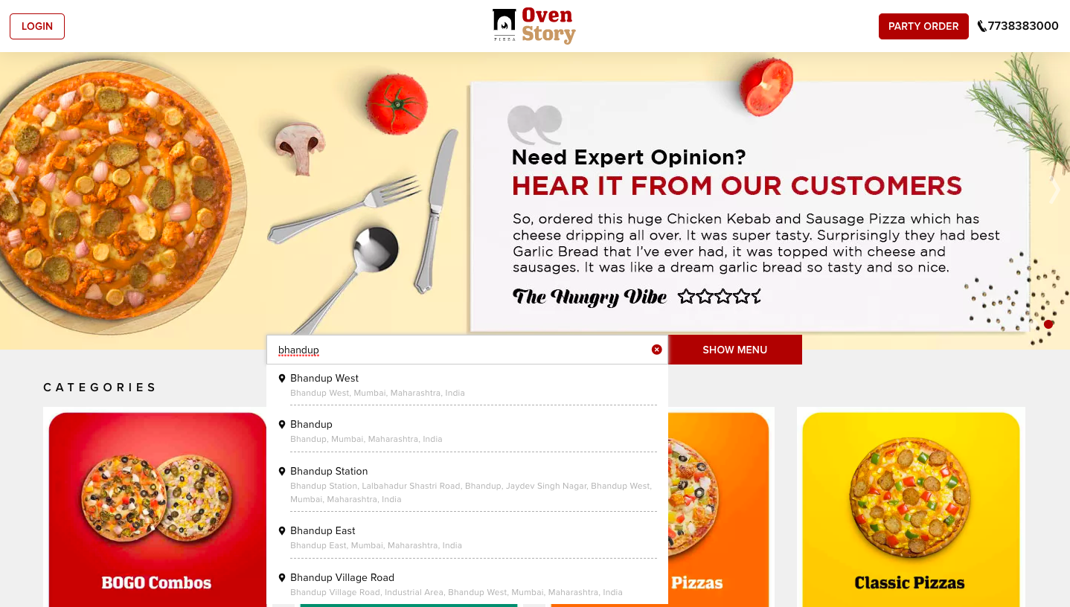

Steps:

1. Go to the website <https://www.ovenstory.in>
2. Click on Type Delivery Location
3. Enter Bhandup West Location
4. Go to Collection page.

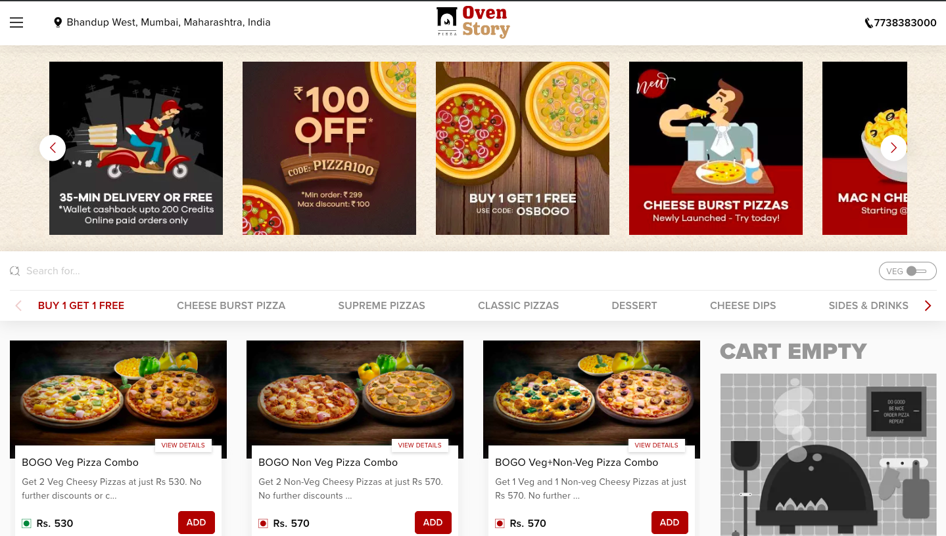

1. Click on Add Button
2. If product is customizable, customize window will appear , Or else just click on Add Button
3. Click on Next button if customize window open and add customization.

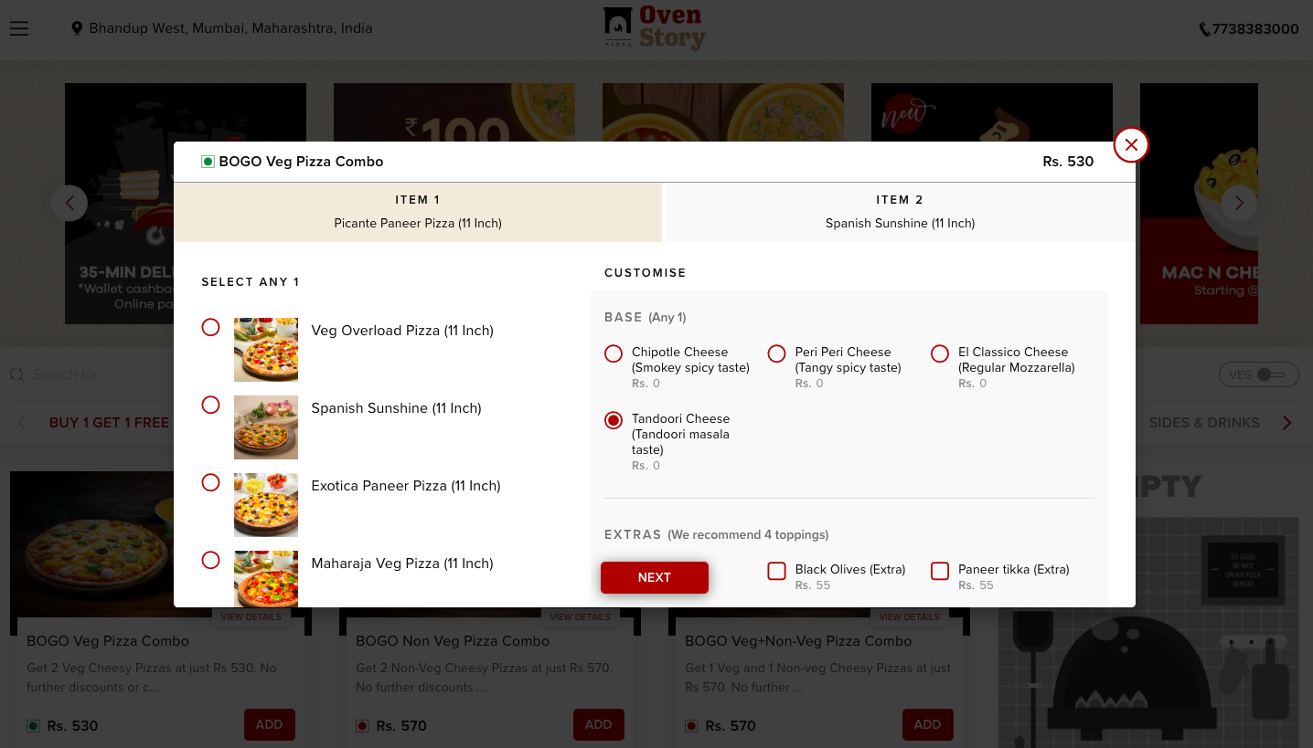

1. Add Product to cart

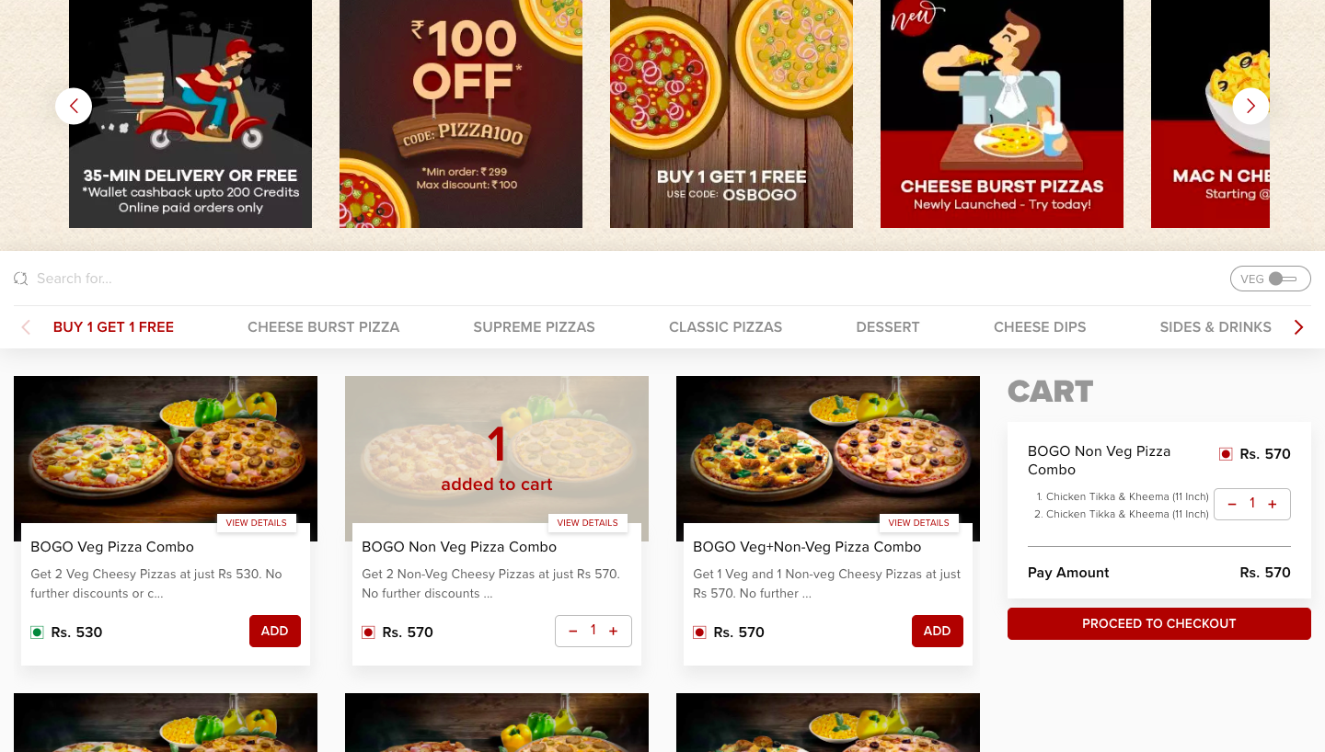

1. Click on Proceed to checkout button
2. Move to Cart Page

Test Case 2: To click on every Side Menu Links.

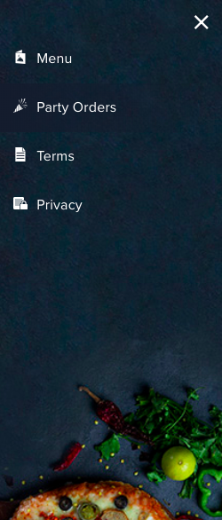

Steps:

1. Click on Side Menu Bar
2. Check every page should get open successfully.

Test Case 3: To change location from collection page.

1. Go To collection page.



1. Click on Location Displayed on Top Left

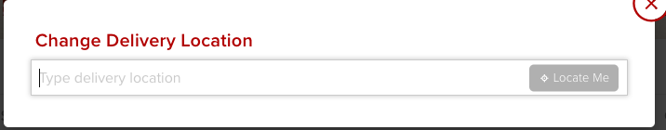

1. Click on Type delivery Location
2. Type Powai and select first option displayed

